**Game Design Document**

Game Concept Document

Functional Concept Document

Graphical Concept Document

Technical Concept Document

Producer**:** Alieke  
Plannager**:** Alieke   
Lead-Dev**:** Faf   
Lead-Artist**:** René   
Level Design**:** Sunray   
User Experience**:** Lara   
Quality Assurance:Everybody

**Introduction**

**Concept**

* Introduction

**The island of Crete has been abandoned. Every nine years, King Minos would make King Aegeus pick several children to be send to Daedalus’s creation, the labyrinth underneath King Minos his palace. They would get eaten by the Minotaur to please the Minotaur.**

**But this time it was not enough.**

**You play as Theseus, son of King Aegeus. He is sending you to Crete to defeat The Minotaur who has been the cause of Crete’s extinction.**

Our game will be a small open world game with RPG elements implemented. It takes place in the past on Crete, a Greek tropical island with a lot of ruins. Underneath a part of the ruins is the labyrinth in which the Minotaur resides.  
The island contains enemies that are serving the Minotaur. You can explore the island, fighting servants of the Minotaur and have to find your way inside the labyrinth.  
The main theme consists of Greek mythology with mythical creatures. We have twisted Theseus his story a bit to our likings. This allows us to add more exploring and gameplay to the game.  
We have a main quest and story to follow with scripted events. The game allows for a lot of exploring.

* Story

Theseus was a young warrior. His father was King Aegeus of Athens. King Aegeus wanted him to be a strong man and told Theseus’s mother “*Once Theseus comes of age he will acquire my weapons and travel to Athens”.* When Theseus turned 18 his adventure began. He was able to get his father’s weapons and started traveling to Athens. During his adventures he had fought many warriors and creatures, but now another creature is waiting for him.   
Theseus had arrived at Athens and a messenger came to him.   
  
This messenger told Theseus that his father needed him. Theseus felt honoured and would gladly perform any task his father would give him.   
The messenger said” The *Island of Crete has been abandoned. The Minotaur went on a rampage and has enslaved innocent creatures. Your father helped King Minos of Crete to keep this beast calm for many years, but it was not enough this year. King Aegeus wants you to kill this beast before he causes Crete’s extinction”.*  
Theseus was in shock he knew that if he would not succeed something terrible would happen. King Minos would start a war with Athens. This could not happen! Theseus thanked the messenger and started on his journey to Crete.  
  
The journey to Crete was rough on Theseus. He was travelling with a small boat until a mighty storm came and swept him in the water. When Theseus woke up he realised he had drifted to a shore*. “Where am I? Where is my Armor?”* he said.   
Suddenly the same messenger came flying towards him and spoke to him *“You have arrived young warrior, now it is your duty to find this Minotaur and slay him. Your Armor and weapons have stranded somewhere on this island be sure to find them before you encounter the beast”.* And with that the messenger left again.Theseus did not hesitate, he knew what was at stake.  
  
He found his weapons and starting walking towards the ruins of Crete. There he found a door to the labyrinth. Theseus knew that the minotaur used to reside in that labyrinth, he figured that the minotaur would be in there. *“I haven’t found my Armor yet and these weapons are not strong enough to take on a beast like that. I have to find my Armor and a better weapon before I enter”.*   
  
Theseus looked all over the Island of Crete to find his Armor pieces. They were scattered all over the island, but he was able to find all the pieces and quickly put every piece back on.  
“*I don’t think there will be any weapons here. I suppose I have to make one for myself to defeat this minotaur*”. Theseus started looking again, he had a found a few pieces of strong wood and used that to craft his new weapon. After crafting his new weapon, he went and put his weapon in the sea water and wished that Poseidon would bless this weapon and give it strength to defeat the minotaur.  
  
Theseus entered the labyrinth. The ceiling was completely broken down and the sunlight was shining brightly. The labyrinth had many rooms and Theseus knew that these rooms could be dangerous. As he walked further into the labyrinth he found the first room with lots of big tiles on the floor. He stepped on one of the tiles and suddenly it started to crumble away. Theseus jumped away and stepped on another tile, spiked jumped out and pierced his feet. He quickly walked back and realised the room was filled with traps! Theseus tries his best to dodge them all, but he got wounded in the process.

This wouldn't stop Theseus, he continued to venture further into the labyrinth.

The second room he entered was swarmed with satyrs. Theseus was able to fight them off and went further into the labyrinth.

Eventually Theseus saw a large door. This door was definitely large enough to fit a minotaur. Theseus knew this was it*. "This is it. I will defeat this beast save Athens and make my Father proud."*

Theseus pushed the heavy door open and there he saw the Minotaur. The Minotaur was enormous, wielding a long axe and growling loudly. He had spotted Theseus and started walking slowly towards him.

Theseus noticed how slow the Minotaur was, he thought to himself. *"I could use this to my advantage"!* The Minotaur tried to hit him with his axe, but Theseus was too fast.

He dodged quickly and attacked the Minotaur. The beast got angry, lifted his axe up high and slammed it to the ground. The ground shuddered and Theseus felt numb. He was stunned and couldn't move. The minotaur took his chance and struck Theseus.

Theseus fell back, but wasn't ready to give up yet. He saw the minotaur rising his axe high again and quickly ran towards the back trying to dodge his attack.  
While the Minotaur slammed the ground, Theseus was able to strike him from behind and defeat him in one powerful hit!   
The Minotaur fell to the ground and died. Theseus had done it, he had defeated the Minotaur and fulfilled his task. *“I did it; my father will be proud. I saved Athens”* he said proudly. His adventure was over and Theseus headed back to Athene.

He was greeted by a crowd of people and his father King Aegeus. Everyone cheered and celebrated for Theseus his victory! King Aegeus thanked his son. Crete and Athene was now at peace once more and Theseus had become a hero.

**Functional Concept**

Controls

In the game you will have to move around quickly while attacking the enemy or exploring the world. When you attack the side you are moving to will define how the attack will look like. So when you walk to the right you will attack from left to right etc. The player will be able to open the crafting system as well.

**Moving:** WASD

**Running**: Left shift

**Looking around:** Mouse

**Attack:** Left click

**Jump:** Spacebar

**Crafting System:** E

Player

* Health

The player will have a health bar which shows his/her current health. When the player dies he/she will be respawned with full health on the start point or, when they die in the labyrinth, in front of the labyrinth.

Enemies

* Satyr

The Satyr will consist of 2 types of Satyr. Long ranged and short ranged.   
The long ranged Satyr will attack you with their bow from a proper distance.  
Short ranged Satyr will attack you from up close with their little daggers. They will attack the player when the player is in range.

* Minotaur

The Minotaur will be the last Boss of the game. He is a slow attacking monster with a big long axe. He has a stun ability that you will have to try and dodge. This ability is very slow so you can see it coming. He will start attacking the player when the player arrives in the boss room.

Game progression

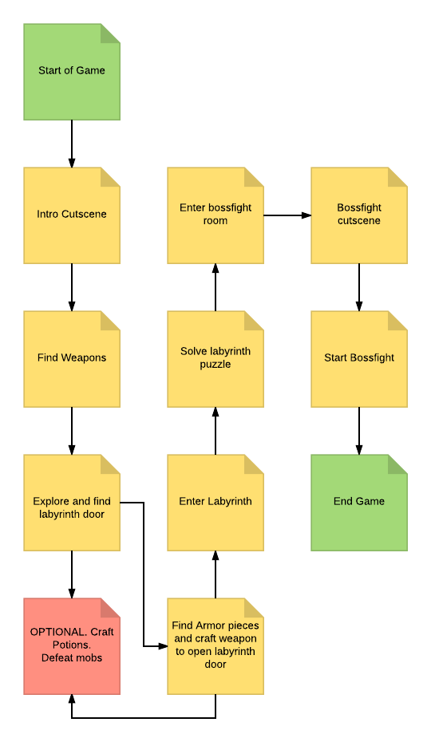

Abilities

The player will earn experience and level up throughout the game. When the player levels up he/she can go to their statistics and put a point in one of their statistics such as: strength, critical chance, stamina, health and defense.

Strength: you will do more damage and have a higher critical damage.

Critical chance: will have a higher chance to crit.

Stamina: you will be able to run longer.

Health: you will have more health.

Defense: You will take less damage from enemies.

To gain health the player will have to collect plants and craft them into a consumable. The plants will grow all over the island to collect. After the player has crafted a consumable it will be called Healthy Herb.

Pick ups

The player will be able to pick up armor pieces before going into the labyrinth. The main character will say he can’t go into the labyrinth because he is too weak and does not have enough defense. So the player will have to collect 4 armor pieces before he/she can go into the labyrinth. The pieces the player will have to collect are:

* Arm guards.
* Boots of Hermes.
* Chest plate.
* Helmet.

The pieces will also give defense points.

The player can collect two different kind of plants which will grow all over the island. The first kind will spawn in the more forest area and the second one will only spawn at the beach area. There will be no plants spawning in the labyrinth so before the player goes into the labyrinth he/she will have to collect enough for them to keep them alive. Otherwise he/she will have to find their way out of the labyrinth to collect more.

UI

The UI consist of a couple of elements. You have a health bar so you can see how much health you have. There will be an experience bar so you can see how much experience you have and how close you are to leveling up. There will be a quest panel where you will be able to see what you need to do next. You will be able to see which abilities you have and what the cooldown is through an ability bar.

**Graphic Concept**

Art Style

As art style we have chosen stylized/semi-realistic. We chose this because we think it will bring out the beauty of the Greek mythology very well since the creatures of this mythology are quite detailed and we think they will look more impressive. We expect the environment will look better with this art style as well because we use Greece as a reference and the combination of this landscape with the mythological creatures will look better with looking more realistic. We chose to not make it hyper-realistic because we think it will cost us too much time so we chose to make it more stylized.

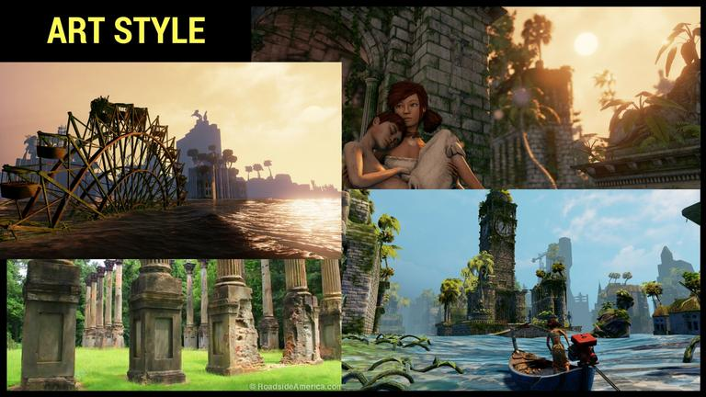

Main Character

Our main character, Theseus, is going to be quite muscular since he is a melee fighter. Since its first person you will mostly see his arms, we are going to give him bracers so the player really gets the feel that he is not just a random person.

Enemies

* Satyr

Our most common enemy will be a Satyr. They will be half human half goat. With legs like a goat, claws for hands and horns. They will stand up straight.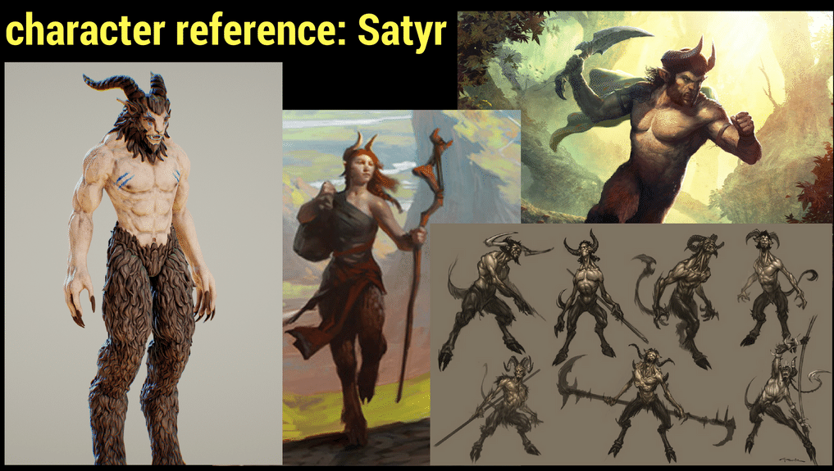

* Minotaur

The Minotaur is our boss enemy. He will be half human half bull. He origins from the Greek mythology. Is very muscular with big horns. He will stand up straight.

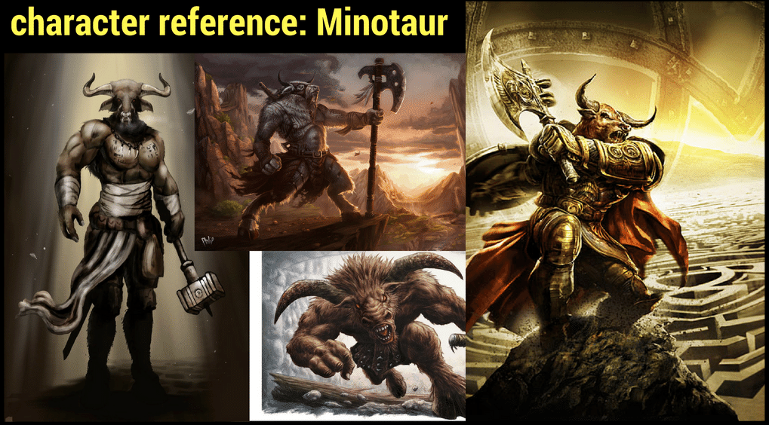

Weapon’s

* Sword

The main character will have a normal Greek sword.

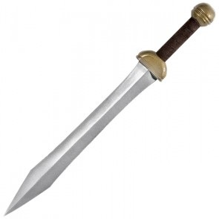

* Trident

Our satyr will wield a trident which is the symbol of Poseidon and the sea.

As the minotaur originates from the white bull of Minos which was a gift to Minos from Poseidon.

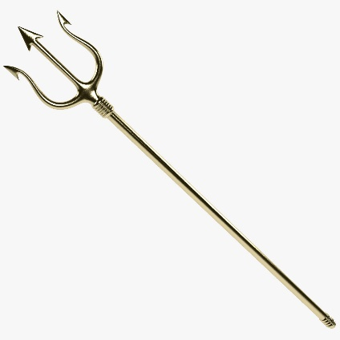

* Double sided axe

For the Minotaur we have a double sided axe because it follows the Greek mythology.

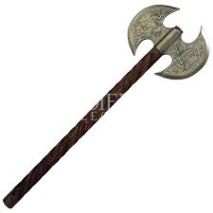

* 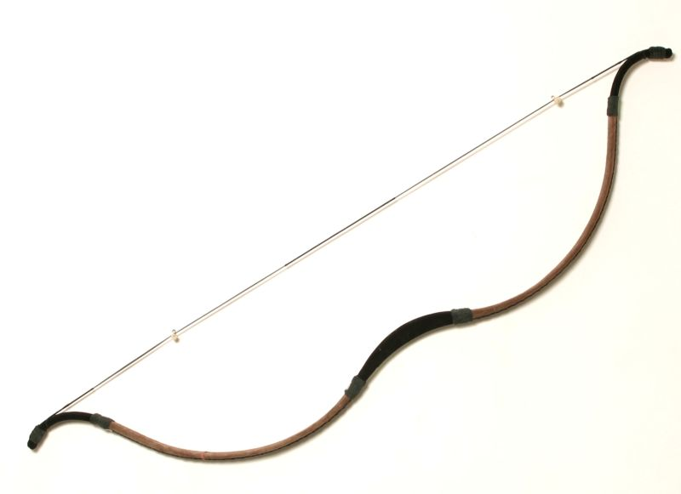Bow (Optional)

As an optional second class for the Satyr’s we have a bow.

Environment

* Ruins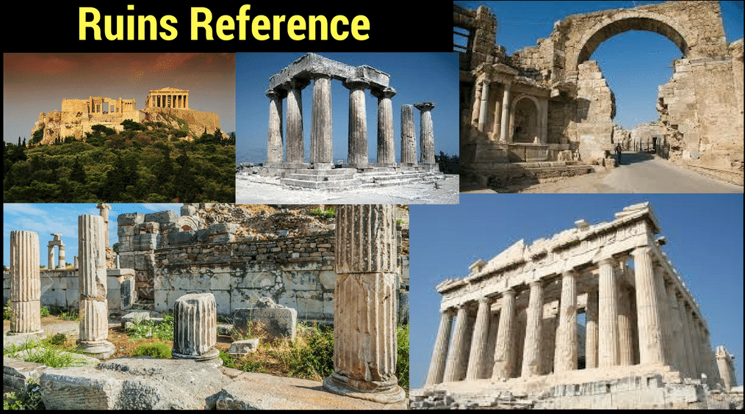
* Labyrinth

In the labyrinth there will be traps to hold you back or kill you.

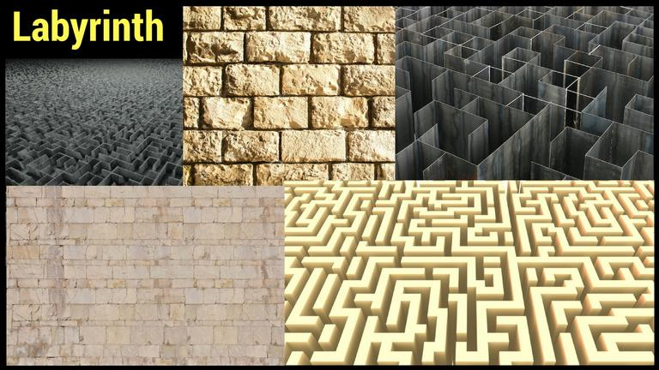

Props

* Craft able plants

The plant in the jungle area will be more of a flower type plant.

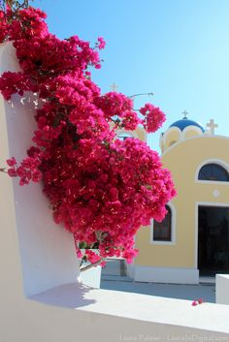 The plant in the beach area will be seaweed.

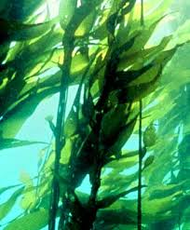

* Armor pieces

UI Concept

* HUD

A concept of how we want the interface. In the top we have an experience bar. On the right you can see the quests so you can always see what you need to do next. In the bottom left you can see your own health bar. In the bottom you can also see your abilities and such as health regeneration ability.

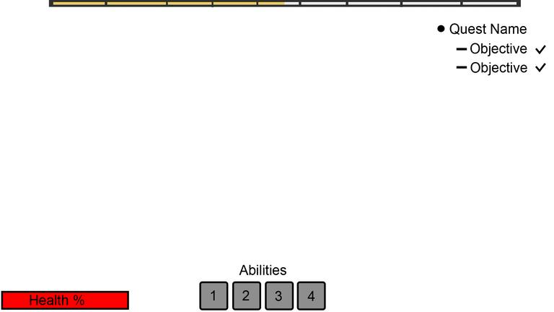

* Enemy health

Satyr

The Satyr’s will get a health bar above their heads. When you look at them you can see how much health they have and you can see if they are almost dead while you are fighting them.

* Minotaur

For the Minotaur we want to give the player the option to always be able to see how much health he has since he is our boss. His health bar will pop up in the interface when you walk into the boss room. By doing this the player will always be able to see how much health the minotaur has left even when not facing him.

Resource budget

|  |  |  |
| --- | --- | --- |
| Object | Estimated Time | Poly Amount |
| Character | 2 weeks | 24k |
| Weapon | 2 days | 3-5k |
| Wall & Pillar | 3 days | 300 |
| Ruins |  | 7-10k |
| Props | 2 days | 1-2k |
| Nature | 2 days |  |
| Animation | 3 hours | - |
| Sound | ½ hour | - |
| Particles | 2 hours | - |

**Technical concept**

System

* Game manager

Will have a DontDestroyOnLoad. Will contain all the statistics.

* Quests manager

This script will contain an enum which contains the different quests states. When the player completes a quest the state of the enum will go to the next one.

* Pause manager

Will set the timescale to zero and give a menu where you can continue the game, quit the game or go to options menu.

* Main menu manager

Will handle all the buttons in the main menu such as: Start game, Options and Quit.

* Load manager

Shows the loading screen.

* Options manager

Here the player will be able to change the options in the game.

* Experience manager

Will contain the current level, experience and all the statistics.

* Player Respawn manager

Will respawn the player at the right position.

Controls

* Moving

We move the player model around by moving the position of the rigidbody. The movement speed of the player will multiply by an acceleration speed when the shift button is pressed but is set to a maximum. The player models will shoot a raycast downwards and until the raycast is false the player model’s gravity will be off. When the player jumps there will be a force added to the player’s y axis.

When the player runs his stamina will drop until it’s zero and he/she won’t be able to run anymore. If the player is not running his stamina will go up slowly until it has reached it’s maximum.

* Attacking

When the player moves to the right the player will attack with the sling of his sword from left to right. When the player moves to his left he will sling his sword from right to left. When the player walks backward while clicking the attack button he will block for a brief second. When he walks forward he will do a normal attack.

Player

* Health

The player’s health will drop once they have been damaged by enemies or traps. When the player’s health drops below zero, he/she will be respawned at the starting point of the area they have died.

* Player Respawn

There will be trigger fields at the start of the labyrinth. When the player goes through these it will determine on which side of the entrance the player is so that when the player dies he/she will respawn at the beginning of the labyrinth or the starting point.

Camera

The camera will be a child object of the player model. The camera will be moved according to the position of the mouse. When the mouse is moved up and down the camera will be rotated up and down. When the mouse is moved left and right the player model will be rotated on the y axis.

Enemies

* Satyr

A sphere collider will check if the player is nearby a Satyr. When the player is inside the sphere collider the Satyr will start chasing the player. When the player is outside of the max range the satyr may walk, the satyr will go back to his patrolling state.

A Satyr can have two different kind of patrolling behavior. The first one if walking around between waypoints. The second one is standing still and looking around.

[attacking and animations]

* Minotaur

When the player walks into the boss room the minotaur will walk around slowly and have big, slow attacks. In a set amount of time he will do his ultimate attack which will stun the player if he/she gets hit.

Abilities

* Experience

The player will have to gain a set amount of experience each level and the higher level the player gets the more experience he/she will need for the next level up. When the player levels up he/she will be able to open a panel in which he/she can add a point to one of their statistics.

* Crafting

The player will be able to open a panel in which he/she can see how much of each plant they have and to click a button with which they can get a crafted item. When they craft something the amount of with which they craft it will go down and the crafted item amount will go up.

Pick ups

* Craftables

The two craftable flowers will have set locations where they will spawn. After you have obtained an item it will respawn in a set time. To obtain them you will have to right click on it. After that it will destroy and will appear in the inventory.

* Armor pieces

After you activated the quest to collect the armor pieces when you find an armor piece, you will have to press right mouse button to collect it. After that the item will destroy and it will appear in the inventory. The player’s statistics will be updated. There will be a message displayed saying you have obtained the item.

UI

* Health

The health bar will have the mask component. The content health will have the image type to filled. By manipulating the fill amount the amount of health shown will be changed.

The fill amount you will have to calculate by fill amount = current health / max health.

By using lerp we will make it look smooth.

* Experience

The experience bar will have the mask component. The content experience will have the image type to filled. By manipulating the fill amount the amount of experience shown will be changed.

The fill amount you will have to calculate by fill amount = current experience / max experience.

By using lerp we will make it look smooth.

* Quests

When the enum updates, there will be a strings updating the text in the quest panel.

* Inventory

In the item slots in the bottom of the screen the inventory will update according to what items you have collected and how many Healthy Herbs you have made.